Nang Thiri Wutyi

20113

9/23/2024

**Verilog Lab Week #1**

1. **“Hello World” in Verilog**

//-----------------------------------------------------

// This is my first Verilog Program

// Design Name : hello_world

// File Name : hello_world.v

// Function : This program will print 'hello world'

//-----------------------------------------------------

module helloWorld;

initial begin

$display ("Hello World!!!");

#10 $finish;

end

endmodule // End of Module helloWorld

**Results** 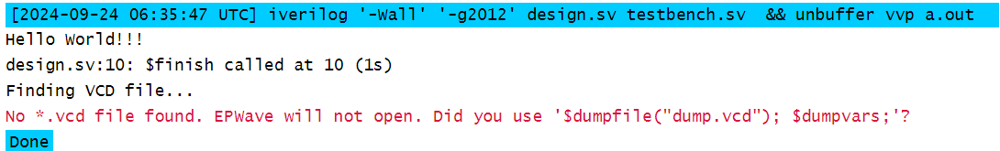

1. **The digital circuit schematics based on the module gate**

**Main module “gate”**

module gates(

output wire out0, // Declare outputs

output wire out1,

output wire out2,

input wire in1, // Declare inputs

input wire in2,

input wire in3,

input wire in4

);

// Logic operations

not U1(out0, in1);

and U2(out1, in1, in2, in3, in4);

xor U3(out2, in1, in2, in3);

endmodule

**Testbench for gate**

// Testbench for the "gates" module

module testbench();

// Inputs to the gates module (reg type for testbench)

reg in1, in2, in3, in4;

// Outputs from the gates module (wire type)

wire out0, out1, out2;

// Instantiate the "gates" module

gates uut (

.out0(out0),

.out1(out1),

.out2(out2),

.in1(in1),

.in2(in2),

.in3(in3),

.in4(in4)

);

// Test logic

initial begin

// Display the header

$display("in1 in2 in3 in4 | out0 out1 out2");

$display("-----------------------------");

// Apply different input combinations and display results

in1 = 0; in2 = 0; in3 = 0; in4 = 0; #10;

$display("%b %b %b %b | %b %b %b", in1, in2, in3, in4, out0, out1, out2);

in1 = 0; in2 = 1; in3 = 1; in4 = 0; #10;

$display("%b %b %b %b | %b %b %b", in1, in2, in3, in4, out0, out1, out2);

in1 = 1; in2 = 1; in3 = 0; in4 = 1; #10;

$display("%b %b %b %b | %b %b %b", in1, in2, in3, in4, out0, out1, out2);

in1 = 1; in2 = 1; in3 = 1; in4 = 1; #10;

$display("%b %b %b %b | %b %b %b", in1, in2, in3, in4, out0, out1, out2);

$finish;

end

endmodule

**Results**

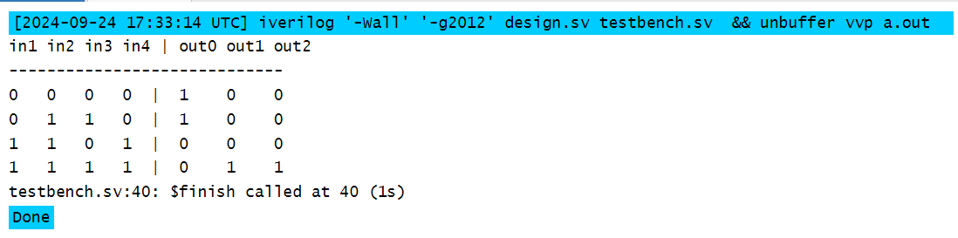

**Digital circuit schematics**

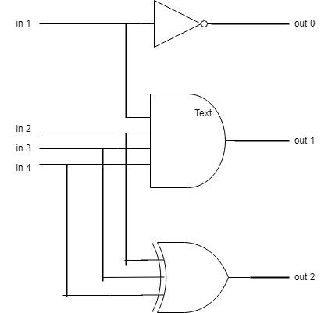

1. **Main Module for oneBitFA1 (Continuous Assignment)**

module oneBitFA1(

input wire a, // Input bit a

input wire b, // Input bit b

input wire ci, // Input carry-in

output wire co, // Output carry-out

output wire sum // Output sum

);

// Continuous assignment to calculate sum and carry-out

assign {co, sum} = a + b + ci;

endmodule

**Testbench for oneBitFA1**

module tb_oneBitFA1;

// Inputs

reg a, b, ci;

// Outputs

wire co, sum;

// Instantiate the full adder module

oneBitFA1 uut (

.a(a),

.b(b),

.ci(ci),

.co(co),

.sum(sum)

);

// Initial block to apply inputs

initial begin

// Apply different combinations of inputs

a = 0; b = 0; ci = 0;

#10 a = 0; b = 0; ci = 1;

#10 a = 0; b = 1; ci = 0;

#10 a = 0; b = 1; ci = 1;

#10 a = 1; b = 0; ci = 0;

#10 a = 1; b = 0; ci = 1;

#10 a = 1; b = 1; ci = 0;

#10 a = 1; b = 1; ci = 1;

#10 $finish; // End the simulation

end

// Monitor to display the results

initial begin

$monitor("At time %0d: a = %b, b = %b, ci = %b | sum = %b, co = %b", $time, a, b, ci, sum, co);

end

endmodule

**Results**

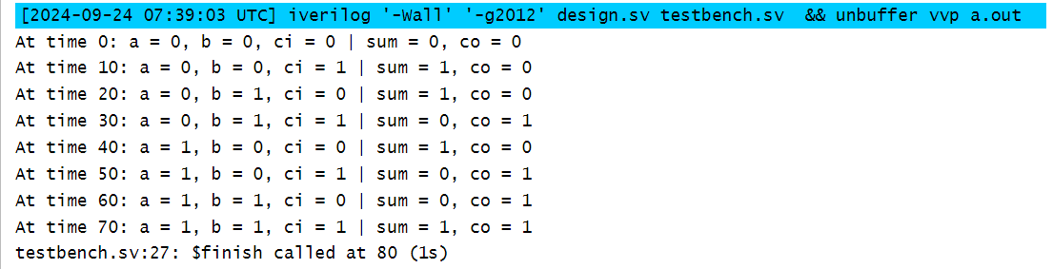

**Main Module for oneBitFA2 (1-bit Full Adder using Always Block)**

module oneBitFA2 (

input wire a_i,

input wire b_i,

input wire ci_i,

output reg sum_o,

output reg co_o

);

// Always block for sum and carry-out

always @(*) begin

{co_o, sum_o} = a_i + b_i + ci_i;

end

endmodule

**Testbench for oneBitFA2**

module tb_oneBitFA2;

// Declare testbench inputs and outputs

reg a_i, b_i, ci_i;

wire sum_o, co_o;

// Instantiate the oneBitFA2 module

oneBitFA2 uut (

.a_i(a_i),

.b_i(b_i),

.ci_i(ci_i),

.sum_o(sum_o),

.co_o(co_o)

);

// Testbench procedure

initial begin

$display("Testing 1-bit full adder using always block (oneBitFA2)...");

$monitor("a_i=%b, b_i=%b, ci_i=%b -> sum_o=%b, co_o=%b", a_i, b_i, ci_i, sum_o, co_o);

// Test case 1

a_i = 0; b_i = 0; ci_i = 0;

#10;

// Test case 2

a_i = 0; b_i = 0; ci_i = 1;

#10;

// Test case 3

a_i = 0; b_i = 1; ci_i = 0;

#10;

// Test case 4

a_i = 0; b_i = 1; ci_i = 1;

#10;

// Test case 5

a_i = 1; b_i = 0; ci_i = 0;

#10;

// Test case 6

a_i = 1; b_i = 0; ci_i = 1;

#10;

// Test case 7

a_i = 1; b_i = 1; ci_i = 0;

#10;

// Test case 8

a_i = 1; b_i = 1; ci_i = 1;

#10;

// End simulation

$finish;

end

endmodule

**Results**

